

Breisach – March 2021

**PRESS RELEASE**

**New Erismann Collection “****Deutschland tapeziert 2”**

**Do it now.**

True to the motto: “No more excuses, it’s time to get wallpapering!”, the initiative “Deutschland tapeziert” is all about highlighting the many advantages of wallpaper. The focus of all the activities is on demonstrating the huge range of design possibilities and the simplicity of application.

As part of this successful initiative, Erismann is now launching its second collection with light, summer-inspired designs and fresh colour accents. The charming leaf motif stands out with its harmonious colour mix of greige, pearl and dark berry in combination with elegant silver. The motif in a fresh mint-bamboo mix is particularly expressive. Partial gloss effects on the leaves add a wonderful finishing touch. The walls are brought to life with the colour-coordinated striped patterns, which are reminiscent of casual uneven brushstrokes. The collection is rounded off by two, weightless plain-coloured structures.

The Erismann collection “Deutschland tapeziert 2” puts the focus on the initiative’s striking logo and thus ensures a coherent overall image at the POS. Sample cards, roll inserts and cardboard boxes all feature the black-red-gold signet of the campaign and thus guaranteed to attract attention on any sales floor.

The campaign comprises a total of 14 paste the wall (blown vinyl) in 4 colour combinations.

The RRP is between € 22.45 and 23.45.

www.erismann.de

No. of characters in running text (incl. spaces): 1350

CONTACT:

Erismann & Cie. GmbH - Hafenstraße 19 - 79206 Breisach

Silvia Reddmann – Head of Marketing/Communications

Phone: +49 7667 909-186 * Mobile +49 151 649 616 16

silvia.reddmann@erismann.de * presse@erismann.de * [www.erismann.de](http://www.erismann.de)

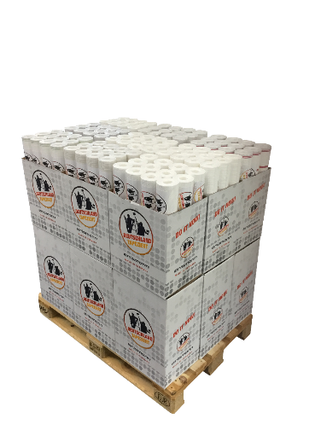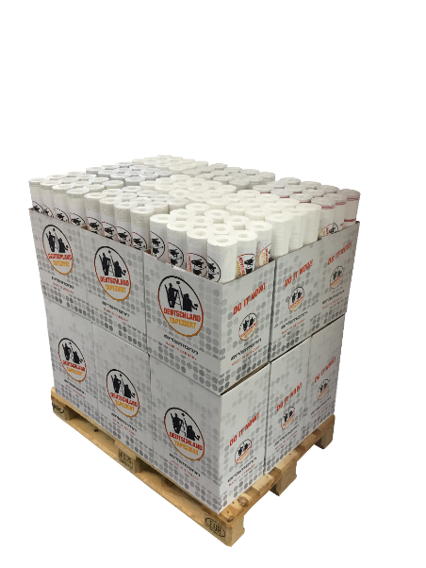**Images:** Photo: Erismann & Cie. GmbH

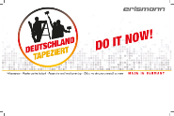

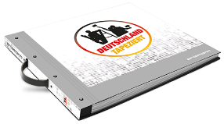

Ein Bild, das drinnen, lebend, Boden, Raum enthält.
