Logo-Erismann

Breisach –Dezember 2020

**PRESS RELEASE**

**Fairyland meets street art**

The new Sweet & Cool collection has a full range of designs to suit everyone from tiny tots of any age to young adults, fulfilling children’s dreams and bringing teens’ iconic culture right into their homes.  
  
The new “Sweety” designs in the Sweet & Cool children’s collection are light-hearted and playful. Little ones will gaze up in wonder at the strings of dainty stars in delicate pink and pale mint twinkling above their head, alongside cute little baby llamas. Combined stylishly with plain wallpapers in delicate shades, they turn a little playroom into a romantic fairyland that can melt children’s hearts. A must-have for cool little lads: the world of cars. Lights flash as fire engines, ambulances, police cars and helicopters whizz through the traffic.   
  
In contrast with the soft, sweet pastel shades for little ones, the cool designs in the Sweet & Cool collection for teens’ walls are truly trending.   
Typography in anthracite stands out in bold relief, for modern rooms that make a black-and-white statement. Racing street skaters recreate the buzzing night-time scene on the streets of New York. The lights of a modern city sparkle in the dark night. The streets echo with rap and soul sounds. And with bold, iconic graffiti in the language of social media – not forgetting that party pizza! – these pieces bring every aspect of young people’s lives right into their bedroom.   
  
A love story: this nonwoven wallpaper embellished with the word “Love” exudes both harmony and restrained elegance. Effectful embossing and delicate hints of gold and metallic hues accentuate the high quality of the “Love” design.  
  
Last but not least:  
A clever combination of patterns and matching plain wallpapers creates a casual yet adventurous living environment for kids and teens that’s bursting with imagination. This top-quality range offers styles of every kind for both girls and boys:  
playful, retro or hip, it’s simply cool!

Zeichen/Wörter: 2029 / 270

Available until 12/2022 / 25 paste the wall wallpapers for children and young people /Price 22,45 € - 23,45 €.

CONTACT:

Erismann & Cie. GmbH - Hafenstraße 19 - 79206 Breisach

Silvia Reddmann – Head of Marketing/Communication

Fon: +49 7667 909-186 * Mobil +49 151 649 616 16

silvia.reddmann@erismann.de * presse@erismann.de * [www.erismann.de](http://www.erismann.de)

**Images**: Erismann & Cie. GmbH

Ein Bild, das Text, draußen enthält.

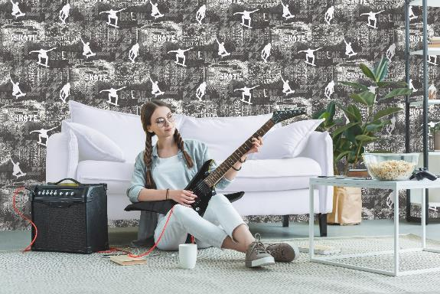

Ein Bild, das Kinderbett, ausgestaltet enthält.

Ein Bild, das drinnen, Wand, Möbel, Schlafzimmer enthält.

Ein Bild, das drinnen, Kissen, hellbraun enthält.

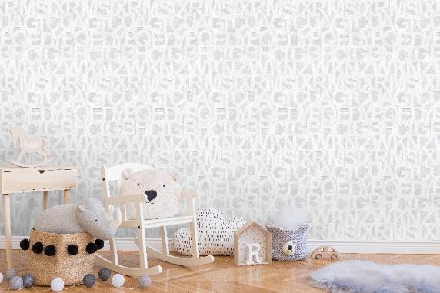

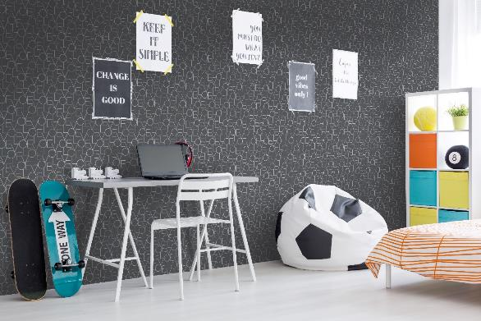

Ein Bild, das Text enthält.

Ein Bild, das Text, Sitz, ausgestaltet enthält.

Ein Bild, das drinnen, Schlafzimmer, ausgestaltet, Möbel enthält.
