Logo-Erismann

Breisach – June 2020

**PRESS RELEASE**

**New Erismann collection “Novara”**

**Fresh, bold and trendy**

The fresh, clear patterns in the NOVARA collection conjure up a great mood and a youthful, bold interior ambience. If you love the latest trends, these wallpapers are a must.

The retro-look circular pattern guarantees a particularly spectacular look. Like pearls on a necklace, straight and graceful, they cast various shadows for a breathtaking 3D effect. Large and small circles, smooth and structured, are evocative in the second circular pattern of air bubbles and dandelions and appear to float across the walls. A bit cheeky and crazy, but still totally stylish. The collection's floral pattern is both playful and vibrant. The petals look as though they have been drawn by hand and, in places, are not yet completed. The colour-coordinated wave pattern impresses with its delicate lines which converge into ribbon-like structures, thus forming a dynamic and weightless atmosphere. Last but not least, NOVARA boasts a trendy, graphic pattern comprising various triangles for a stunning, three-dimensional effect.

Novara offers a broad colour spectrum of plain wallpapers which, in combination with the patterns, set wonderful accents in any room. From cherry red, pink, aqua and pastel shades through to black and white combinations, we offer something to suit all tastes.

**Until: 2022 | Content: 36 paste the wall wallcoverings**

www.erismann.de/en

Text characters (including spaces): 1278

CONTACT:

Erismann & Cie. GmbH - Hafenstraße 19 - 79206 Breisach

Silvia Reddmann – Head of Marketing/Communication

Fon: +49 7667 909-186 * Mobil +49 151 649 616 16

silvia.reddmann@erismann.de * presse@erismann.de * [www.erismann.de](http://www.erismann.de)

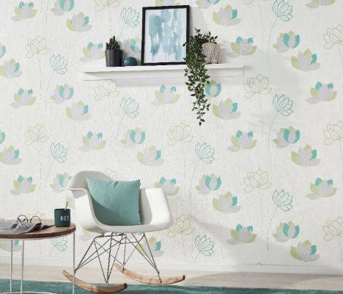**Images**: Erismann & Cie. GmbH

