**PRESS RELEASE**

Breisach, 19.10.2021

**Faded, weathered and steeped in history**

The IMITATIONS vol.2 wallpaper collection is an interpretation of the unique atmosphere of unspoiled nature in an entirely new dimension: Wood, stone and walls that can weather any storm. Striking non-woven wallpapers and digital photo walls from the industrial design age transform modern interiors into fascinating living environments full of contrasts and bold beauty.

Screen-sized urban digital photos flicker across the walls. The BRICKS, FACTORY or INDUSTRIA designs create spectacular lofts with the rugged character of concrete halls, factory walls and raw wilderness. The HANGING GARDEN design showcases a wild garden rising up from the ground, yet tamed by a stone wall or the faded wooden planks in the TIMBER photo design. All five digital designs tell stories that are full of life.

Our non-woven wallpapers also show a harsh beauty. While one wood design creates a vertical wooden wall in faded, dark and earthy tones, another is evocative of narrow ship deck style floorboards made of driftwood. It creates maritime patina effects in pastel shades on the wall.

Stone is inspiring in all variations: Solid whitewashed to red or blue-black brick walls are witnesses to historical factory buildings.

Horizontal slate slabs, rock structures like Jurassic stone or delicate polygonal slabs alternate harmoniously in natural shades and accentuate a timeless elegance. Cool expressive designs reminiscent of concrete round off this extraordinary wallpaper collection.

The non-woven wallpapers and digital photo walls in our new collection IMITATIONS 2 is a celebration of the past, nostalgia and industrial areas in their original form.

It comprises a total of 45 non-woven wallpapers and 5 digital photo walls on non-woven fabric. The paste the wall wallcoverings are available until 12/2023. The RRP is between € 23,95 and 32,95.

Digital Images

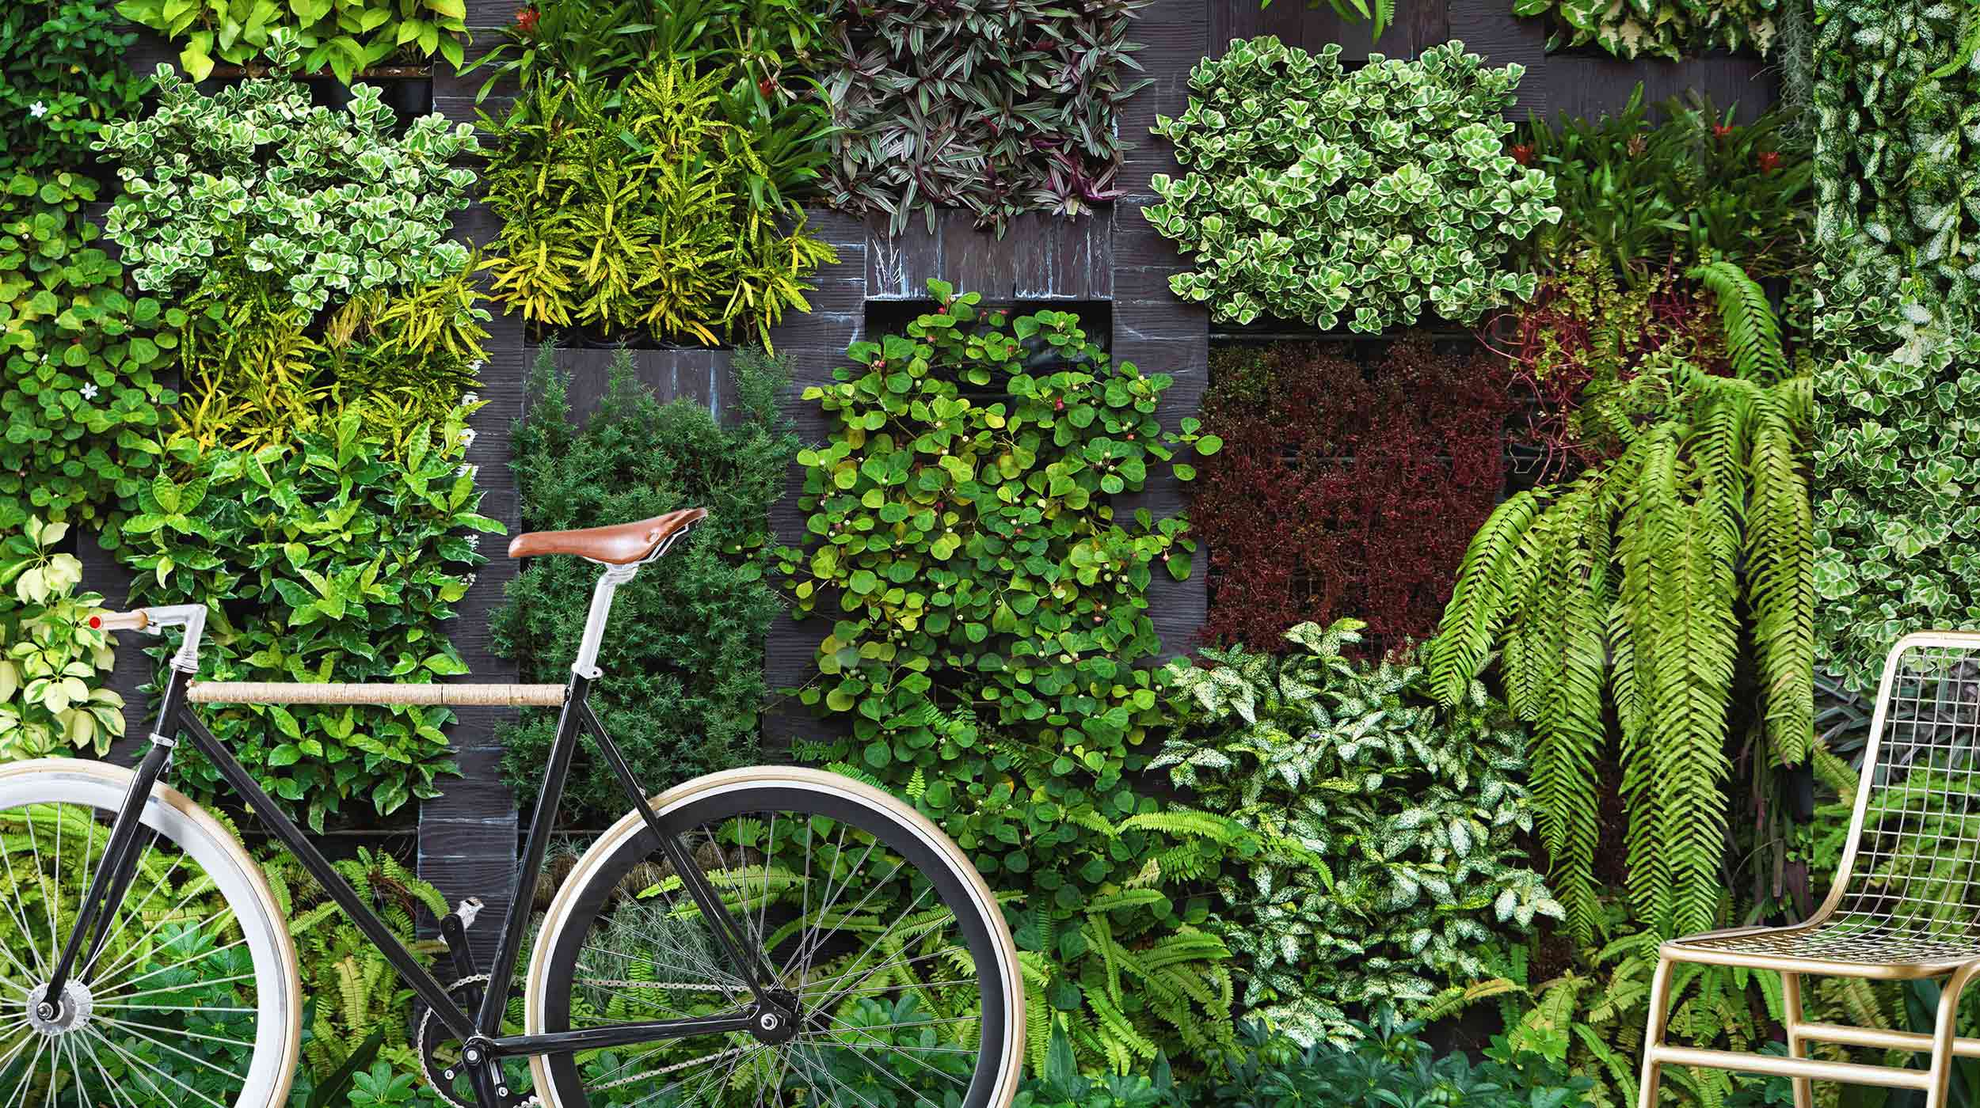

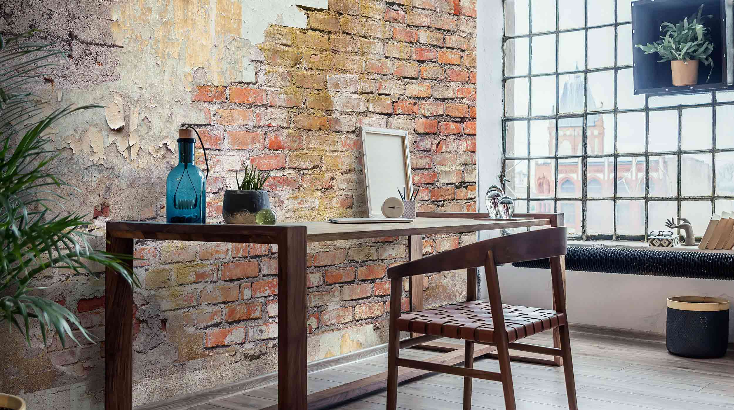

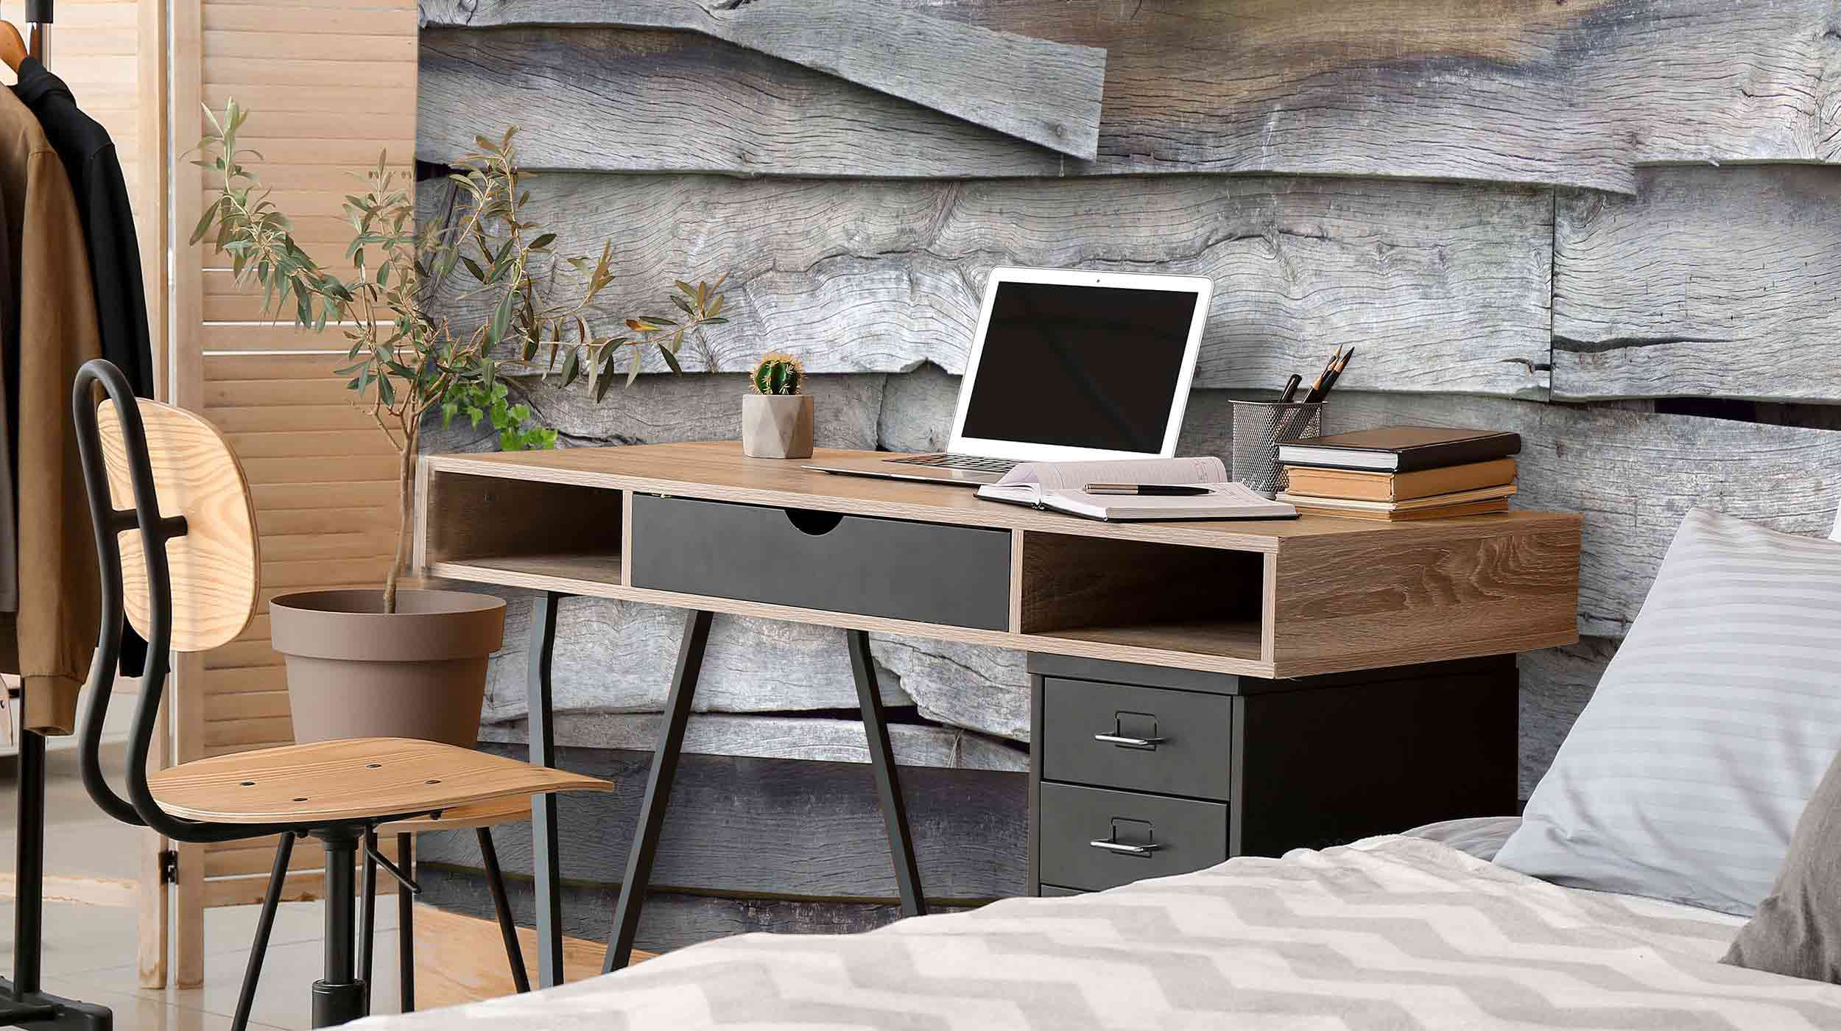

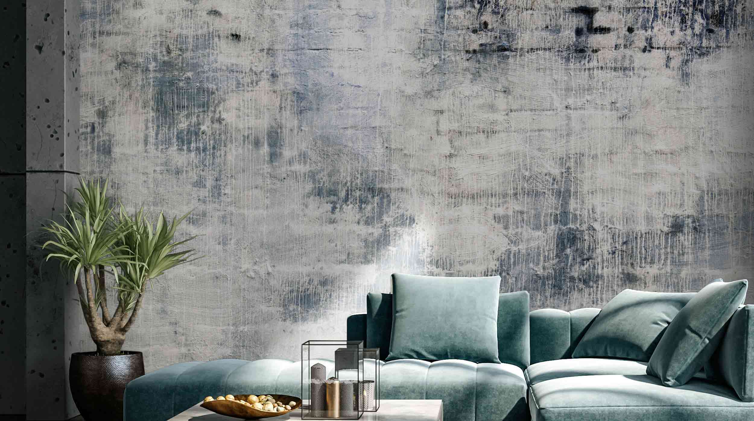

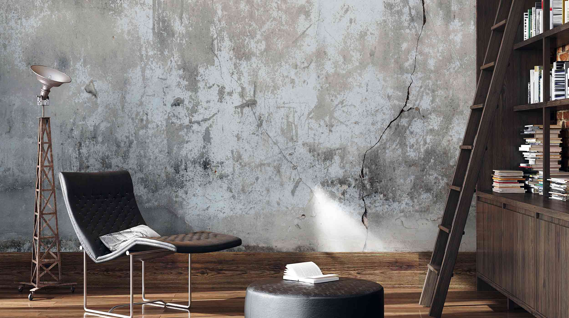

Non-Woven Wallpaper

