**PRESS RELEASE**

Breisach, 16.07.2021

**The new wallpaper collection from Elle Decoration — 'More Beauty 2'**

Wallpapers with passion! This is also true of the 2nd wallpaper collection by ELLE DECORATION from Erismann. Under the motto 'More Beauty 2', she again presents wallpaper designs and inspiration of the highest level — elegant, modern, stylish.

The second Elle Decoration collection comprises a total of five expressive designs for stylish living spaces. In addition to luxurious motifs with breathtaking gloss effects, this collection also features natural themes from extroverted to poetic translucency. The harmoniously coordinated colour palette in combination with an interplay of matt and glossy elements underlines the exclusive character of these high-end wallpapers.

You can indulge in luxury with the AURORA design from the ELLE DECORATION collection. Reminiscent of rays of sun, this pattern sets the scene in a spectacular way. It creates a sensational look on any wall and is an absolute highlight in the 'Live Luxury' interior trend.

Everything flows — that could easily be the credo of the gently swinging motif VELVET.

The glamorous interplay of shape, colour and gloss elements creates a unique wall effect that is reminiscent of the most elegant fabric. Soft colours such as cream beige, anthracite and jade green give the wallpapers a seductive and sophisticated look.

The wave design CURLS shows wallpaper art in its most beautiful form. Delicate lines in refined metallic tones are imaginatively combined with sensual colour gradients. The interplay of perspective and shine gives walls a breathtakingly beautiful liveliness.

The FOREST motif presents a dense jungle full of exotic flowers and leaves. It plays with our eyes and just sparkles with liveliness. Artfully intertwined, the individual wall elements expressively merge to become one. Complete seduction in the new Jungle Look 2.0.

Last but not least: the gentle CALLA motif revels in natural restraint and beauty. The leaves unfold gently and powerfully on the wall and show themselves in a noble translucency. Light, powdery tones emphasise the feminine character of the design, which emanates an intense, sensual aura.

Attractive plain structures complement the Elle Decoration style worlds: three new fresh colours in Aqua, Light Jade and Ecru expand the already wide range of sensual colours in the collection. The nuances range from sand, ochre and grey tones to expressive colours such as glamorous gold, dramatic blue or elegant green tones.

Contents: 35 items

RRPs from €31,95 to 33,45

Available until: 12/24

ELLE DECORATION —wallpapers with passion!

Digital images

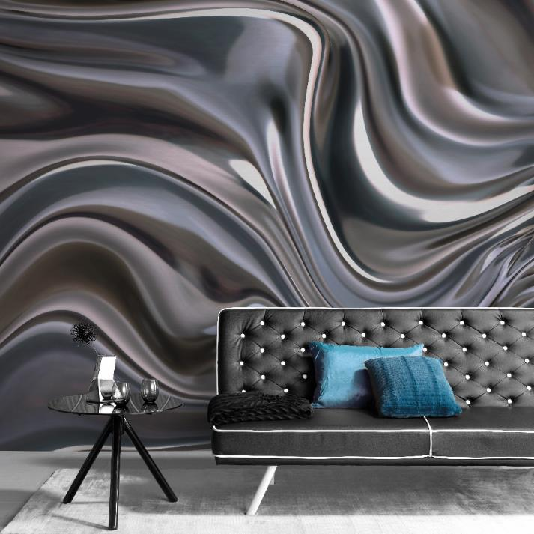

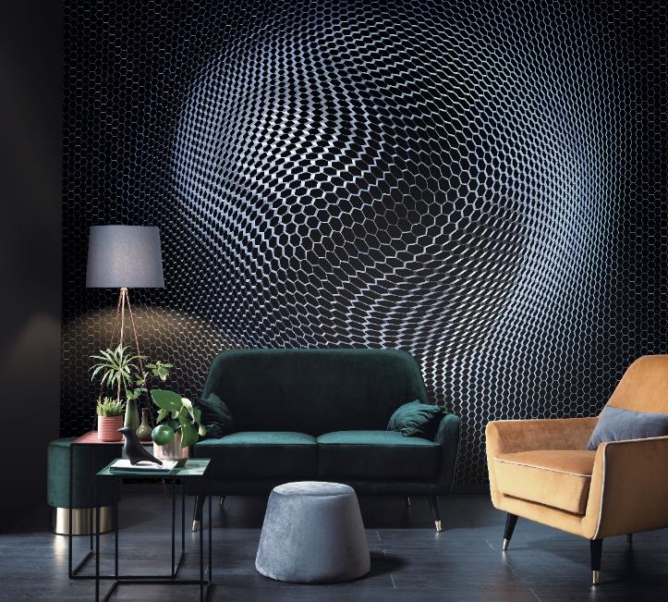

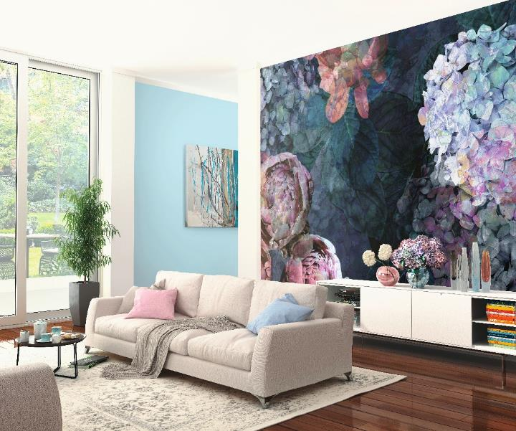

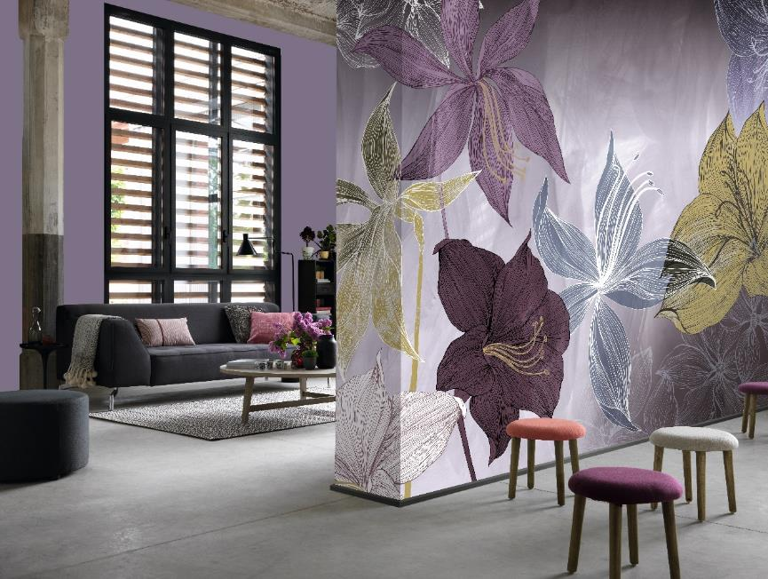

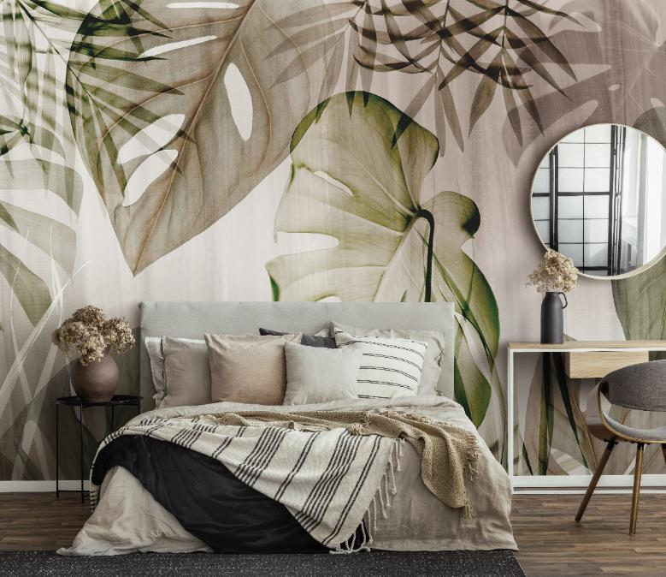

Paste the Wall

